Day 15 React assessment output screenshots of all user stories

User Story 1 output:
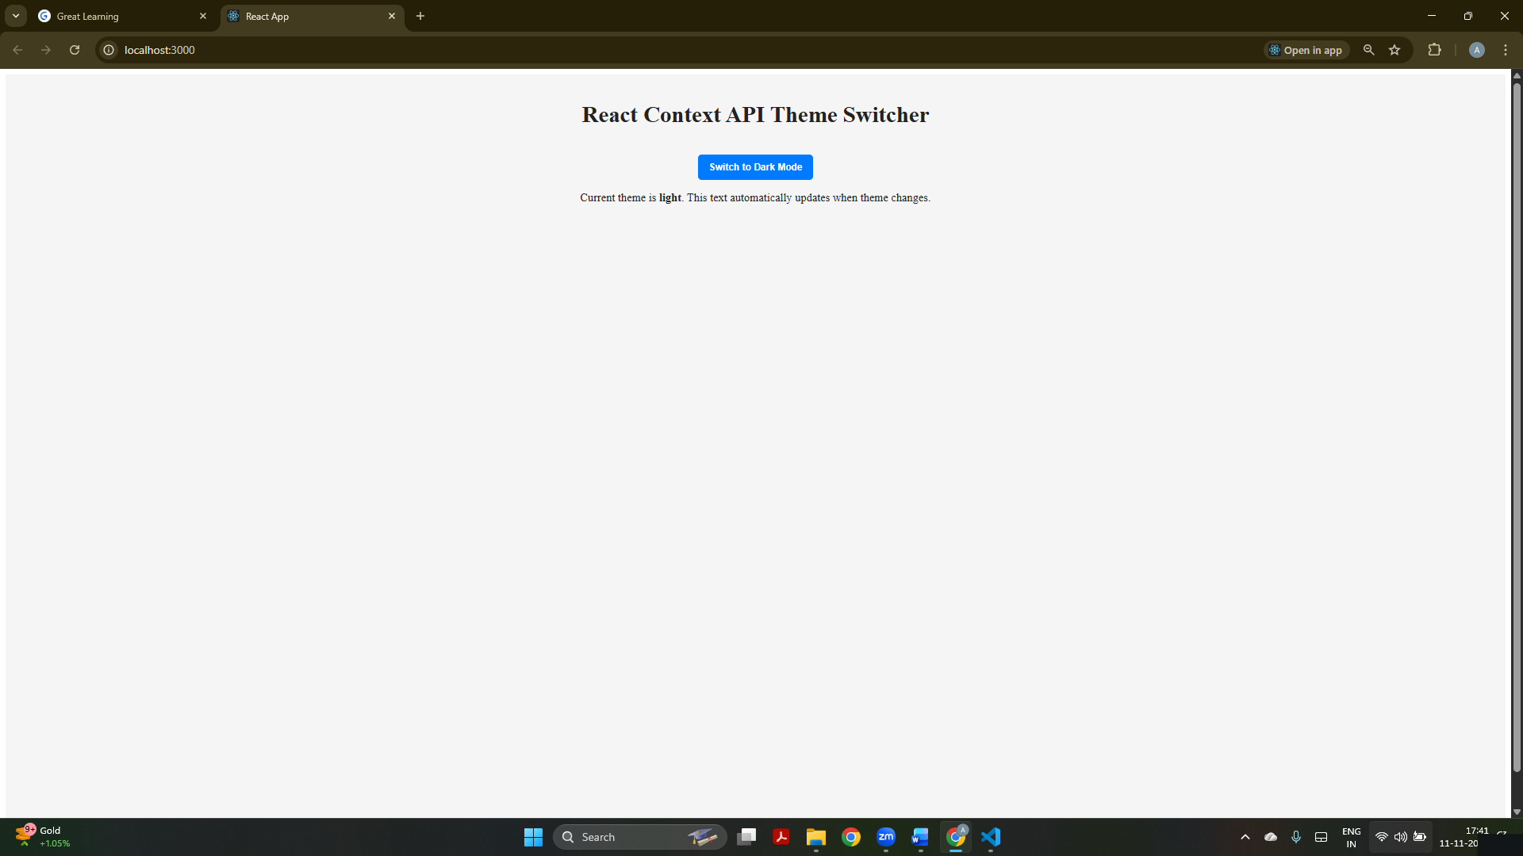
The app is running in light mode showing the React Context API Theme Switcher in its default state.

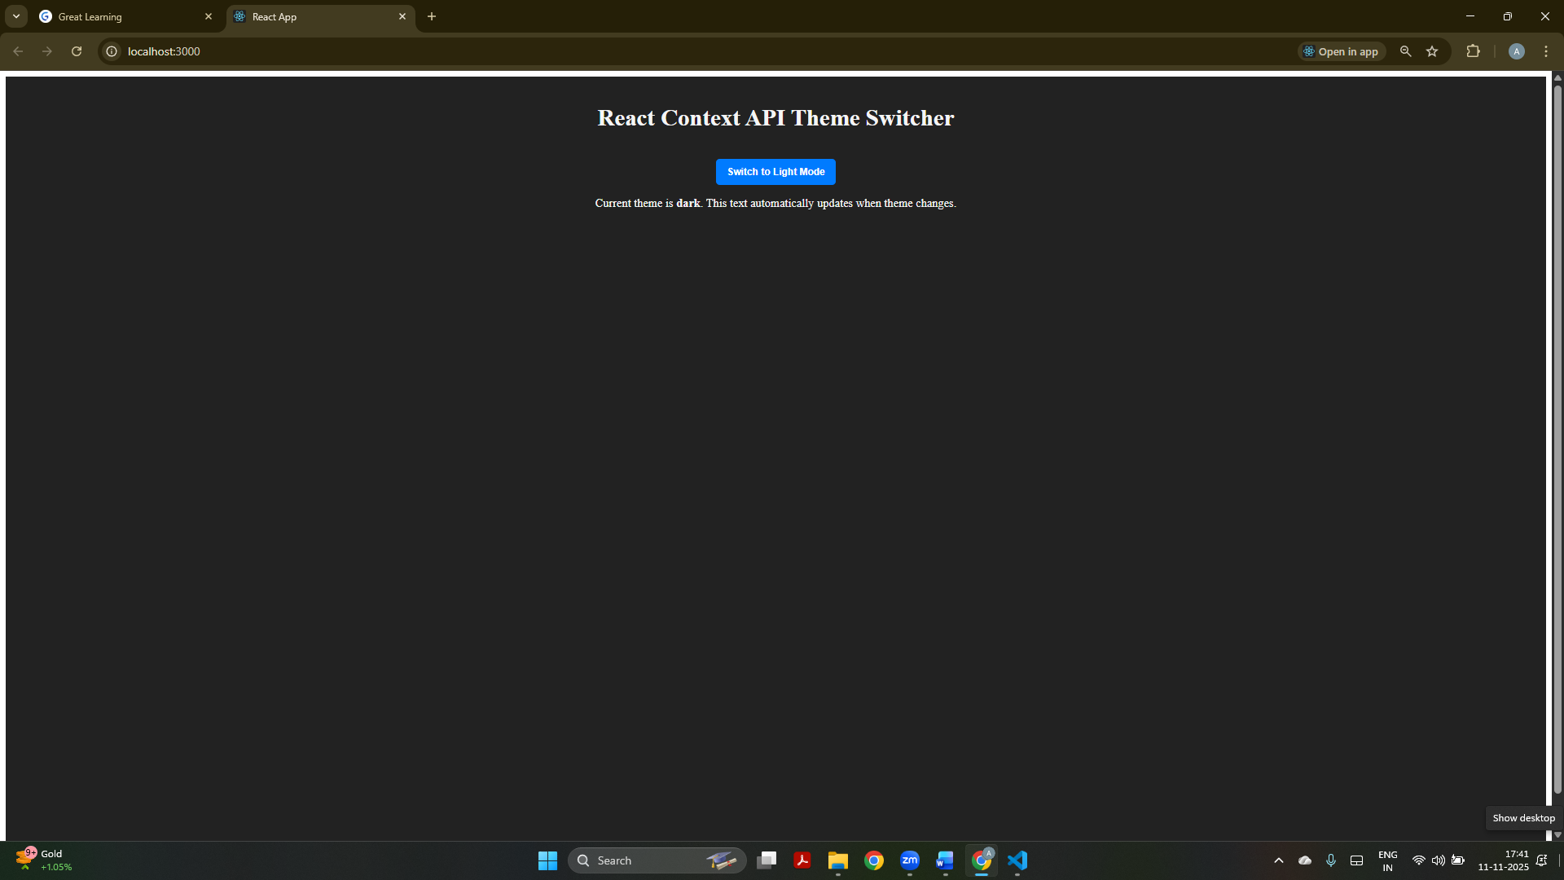
After switching to dark mode using the theme toggle button.
User Story 2 output:
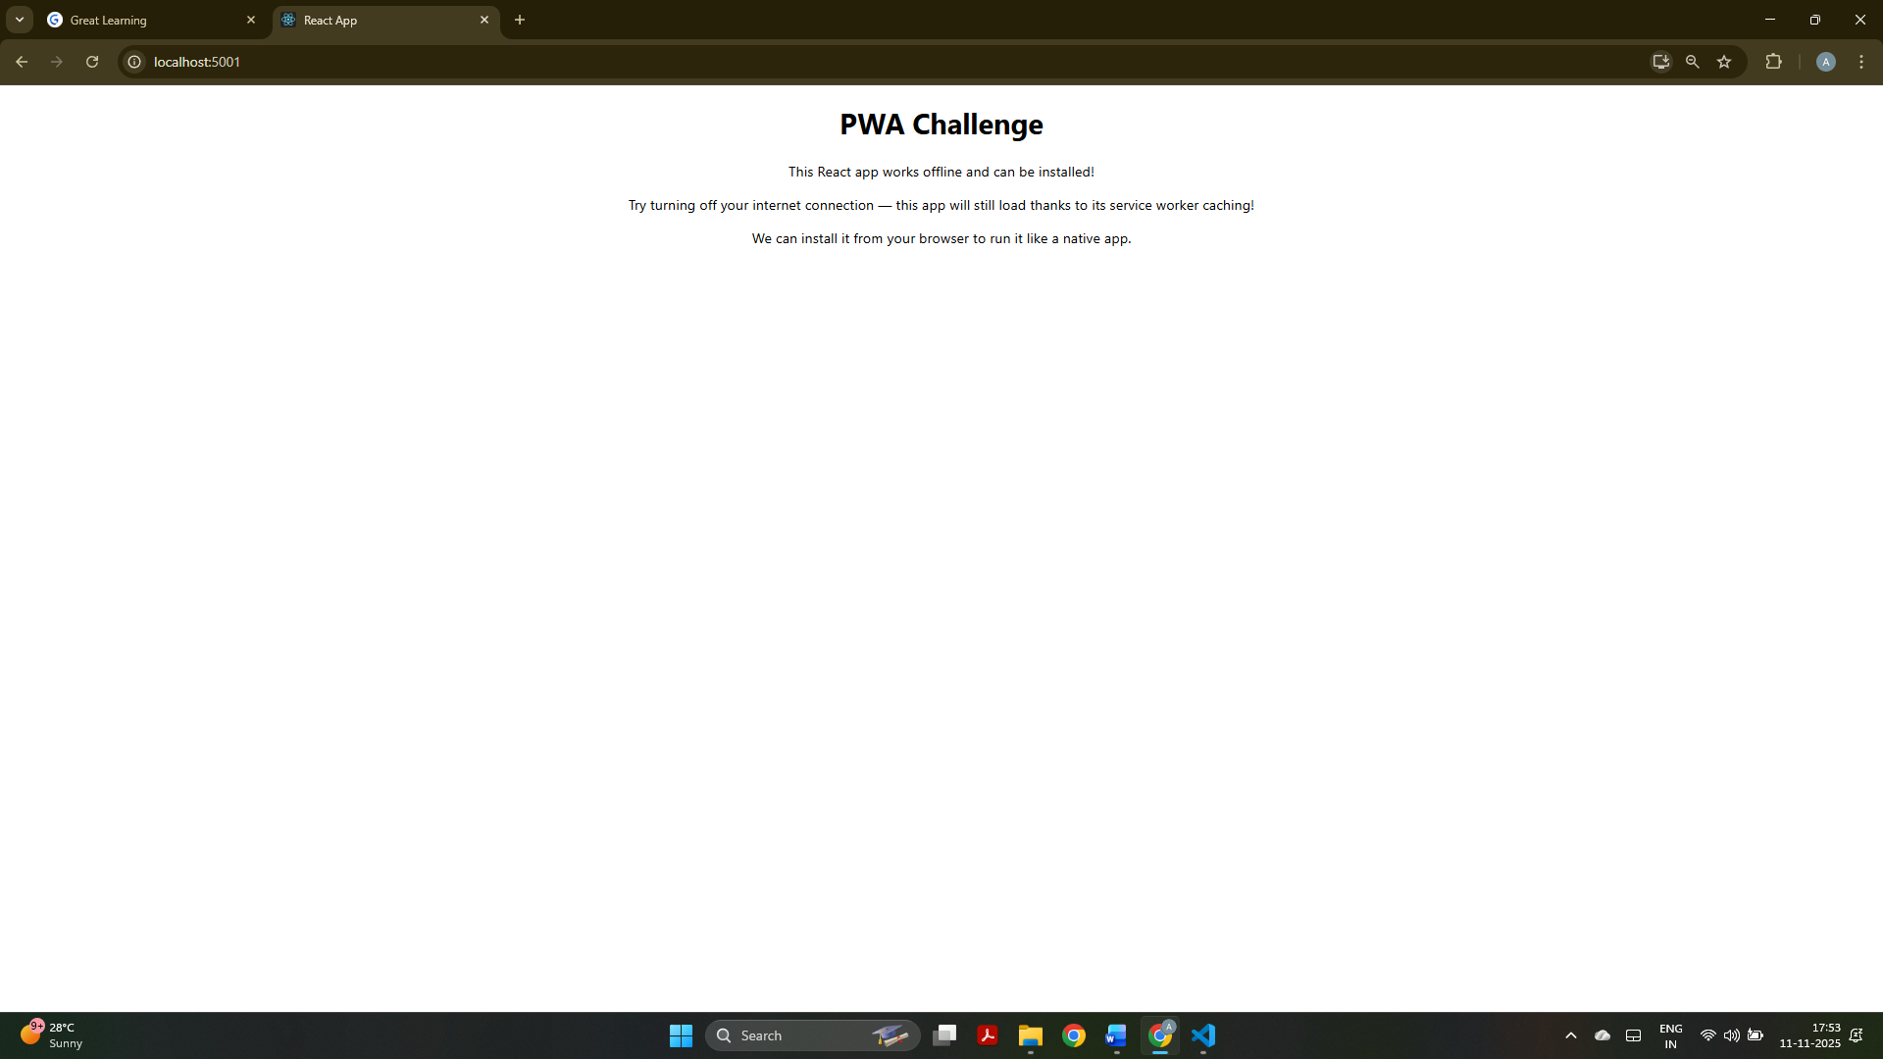
This screenshot shows the PWA Challenge page explaining that the app works offline and can be installed.
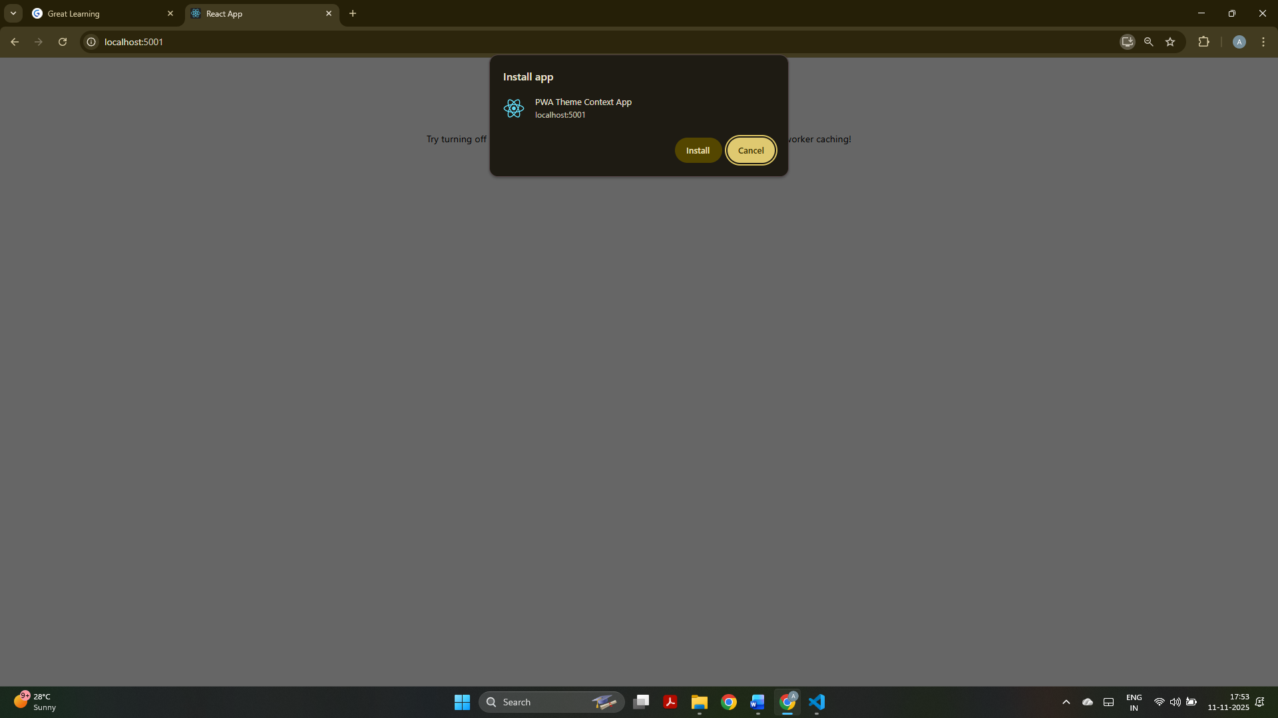
The browser is showing the “Install App” prompt for the PWA Theme Context App.

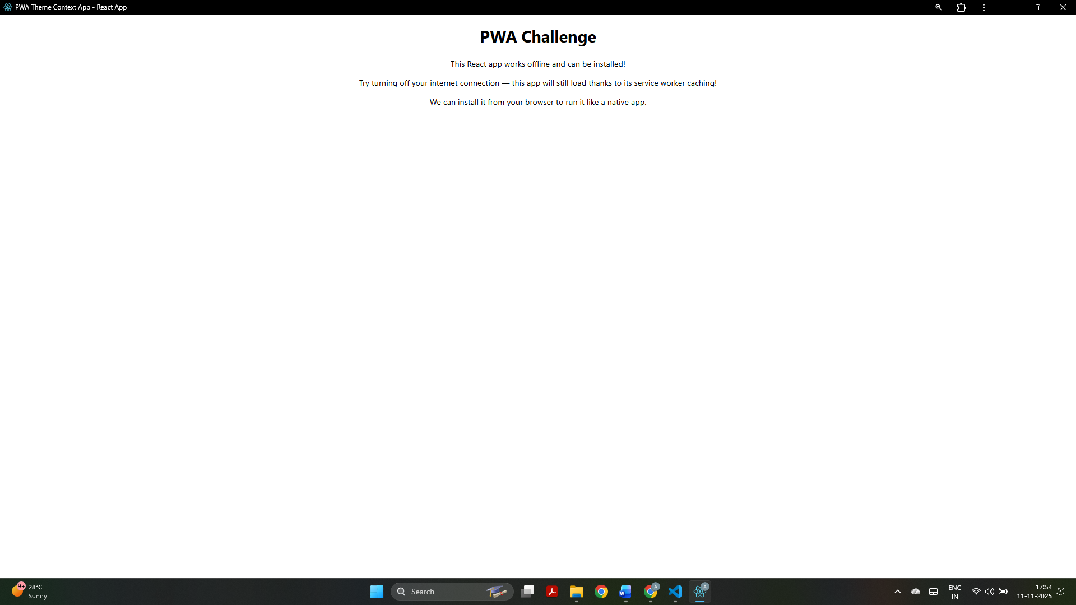
The installed PWA is opened in standalone mode, appearing like a native desktop app.

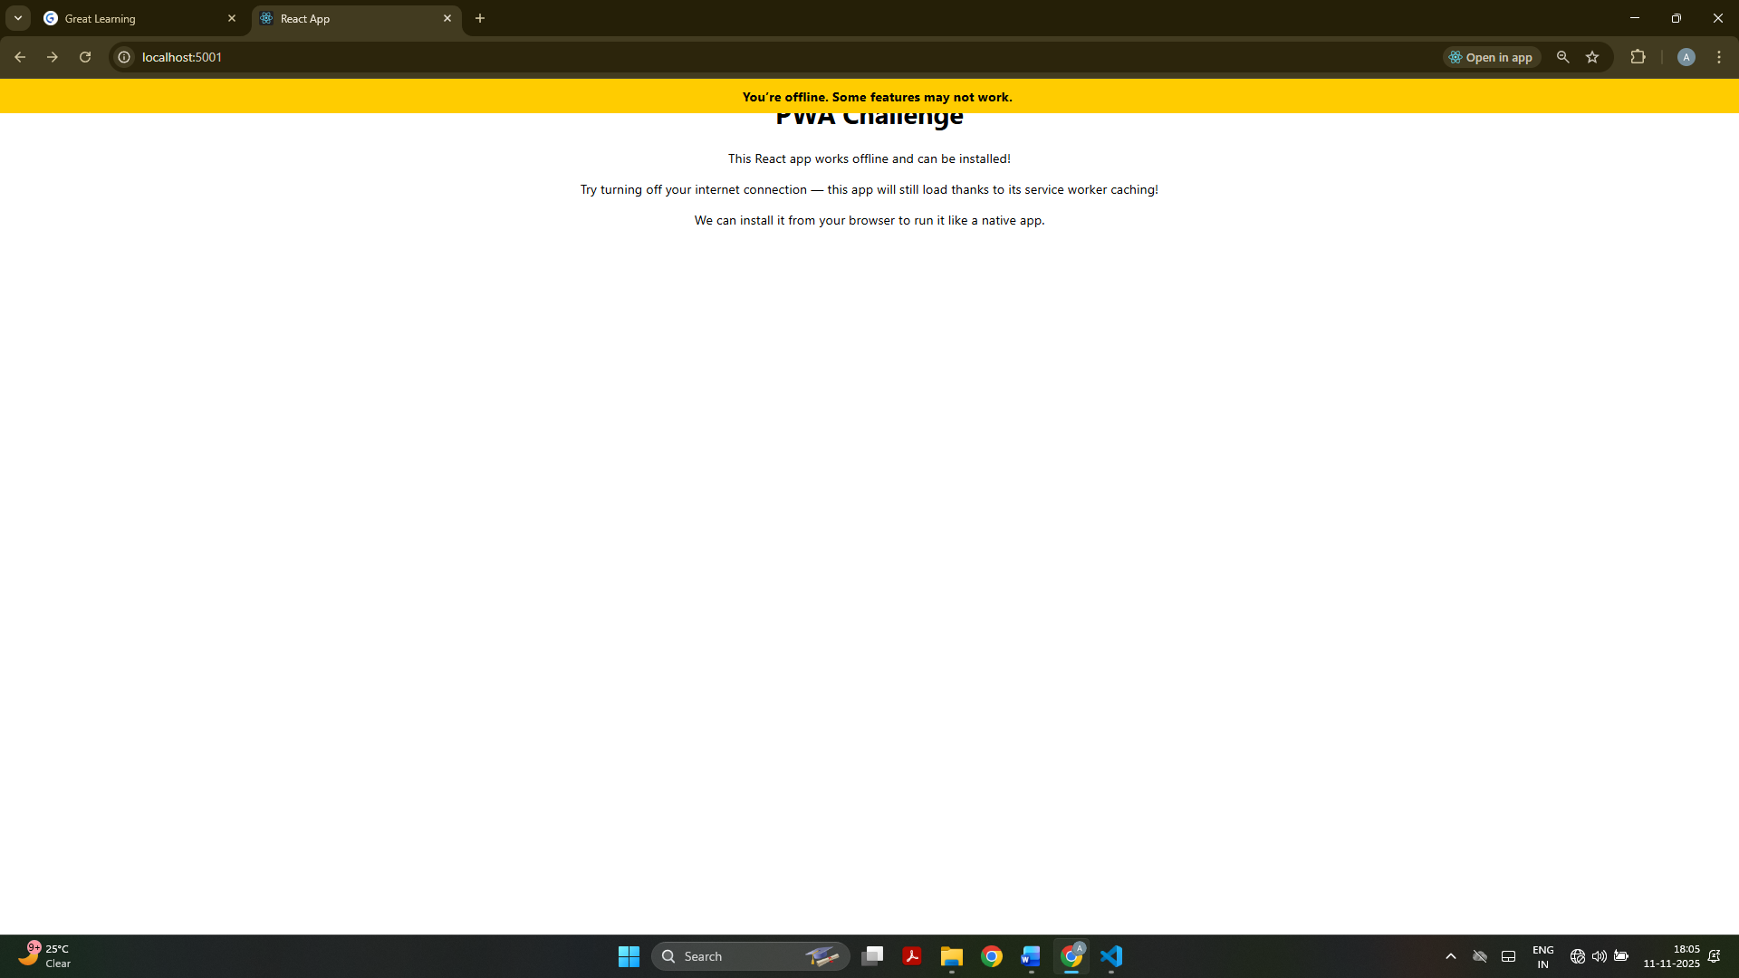
The app displays an offline notification bar while still functioning properly because of service worker caching.

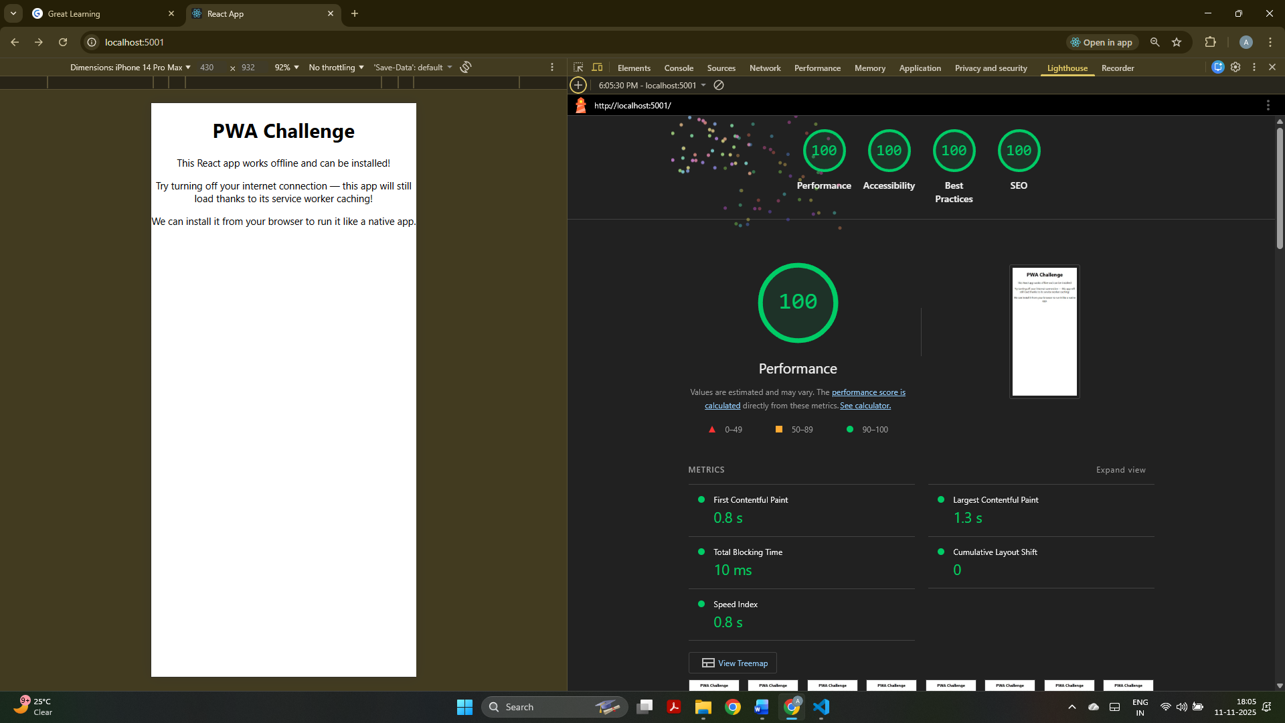
The Lighthouse audit report showing perfect scores for performance, accessibility, best practices, and SEO.

Note: The pwa application is not supported in React 19 version and onwards there were errors encountered while installing normal react app and react app with pwa template. Hence only the lighthouse audit is displayed.

User Story 3 output:
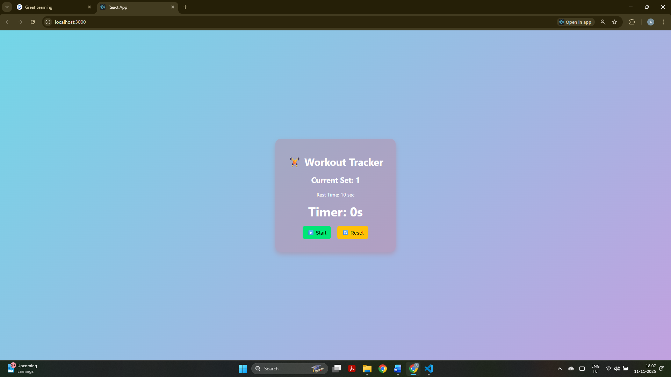
The Workout Tracker app is displayed in its initial state before the timer starts created using React Hooks

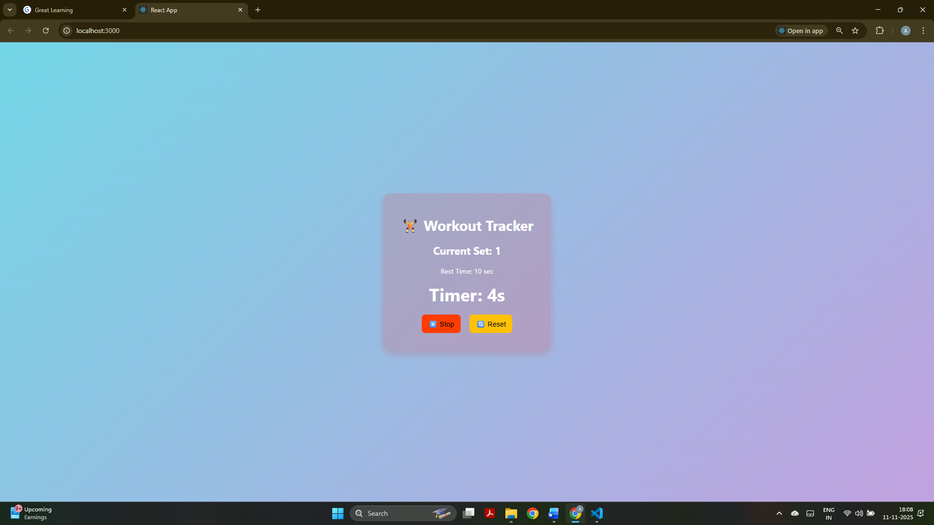
The Workout Tracker timer is running, showing real-time updates as part of the exercise tracking feature.

User Story 4 output:
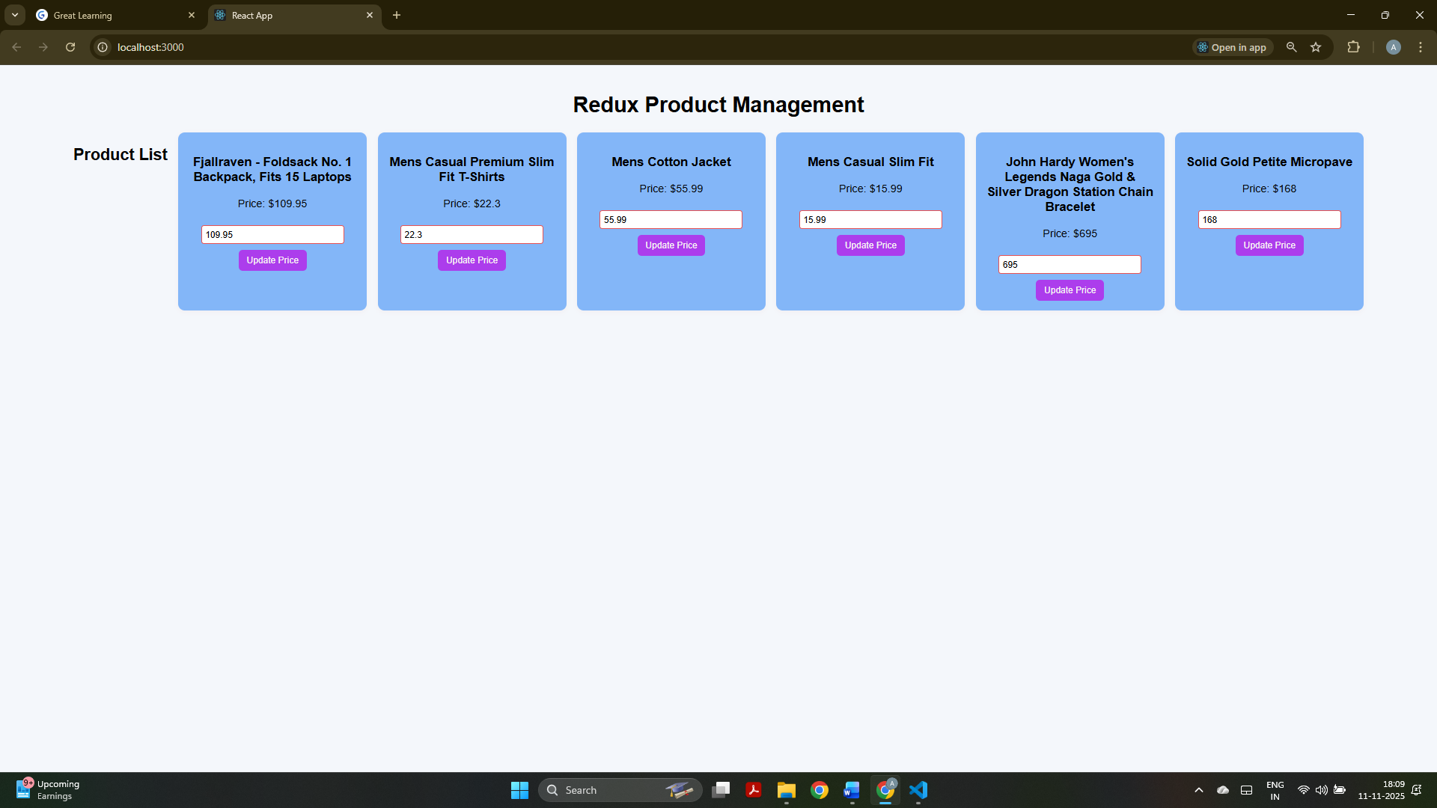
The Redux Product Management page showing product cards where prices can be updated dynamically. Used a fake API to display the products.

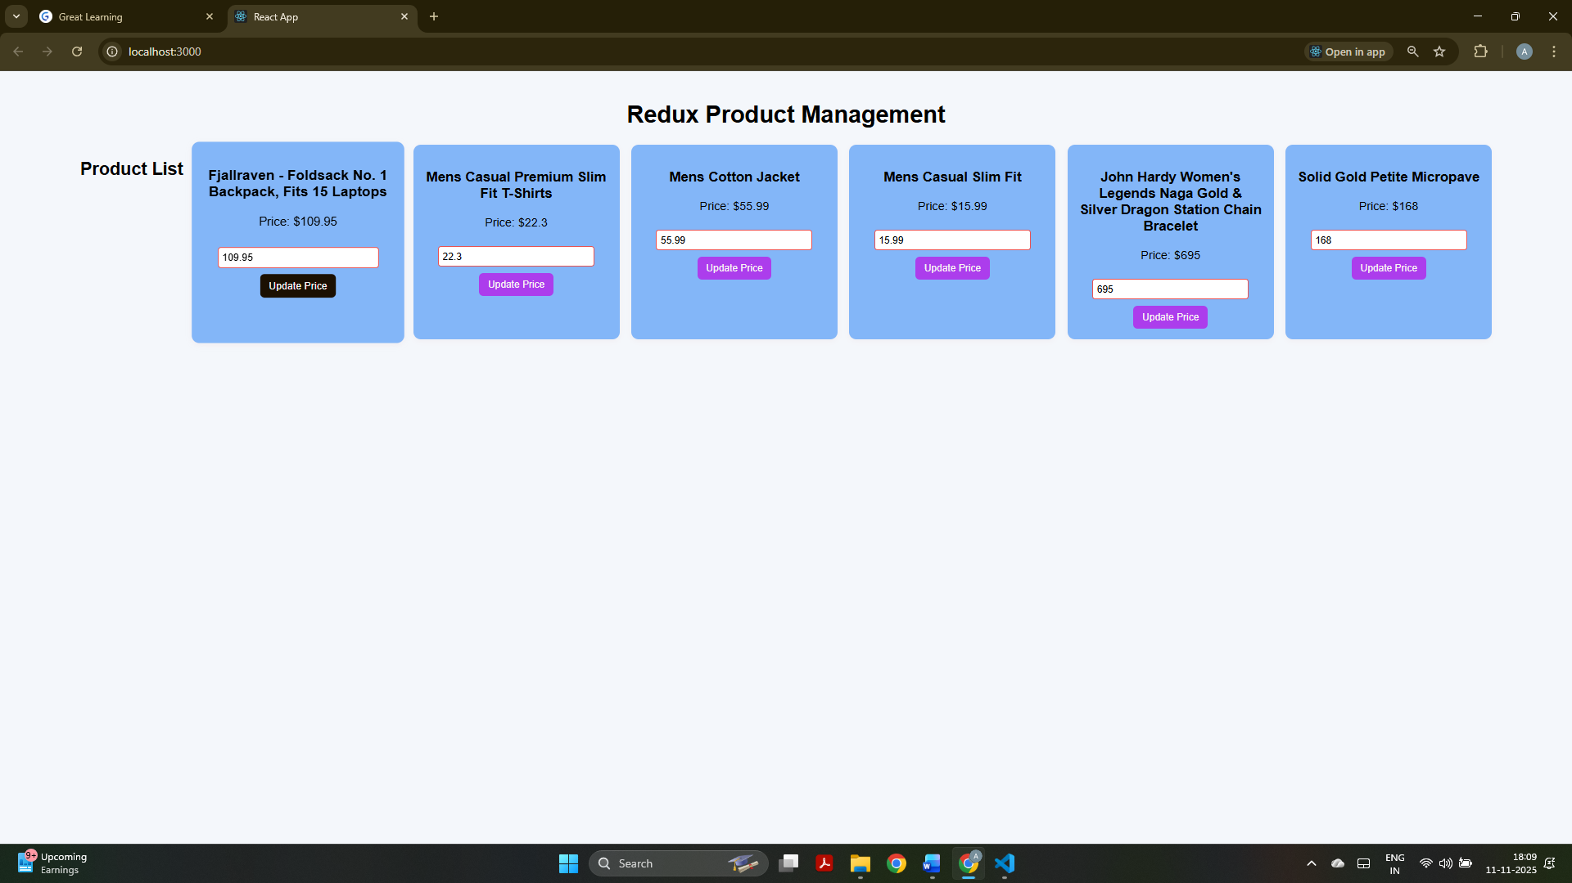
The Redux Product Management page showing the colour change after hovering over the update price button.

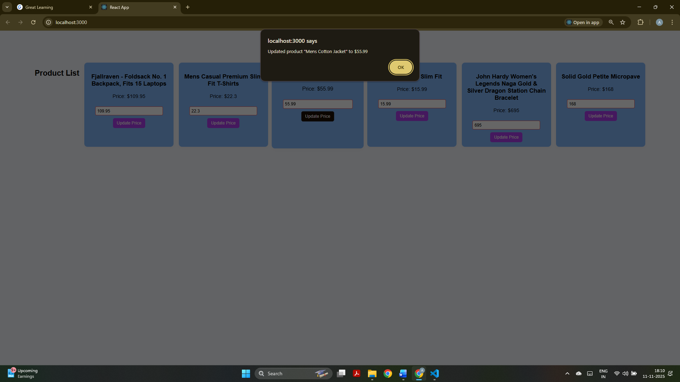
After updating a product price, a confirmation alert pops up showing the updated product name and new price.

